**FLORAL FIESTA**

**Where blossoms bloom and flowers shine!**

**Existing Websites :**

1)Abricot Florist:

**Likes :**

* ChatBot : It helps the users to solve their queries easily and efficiently.
* Sort By : Here, we have an option to sort the products according to our preference and prices which makes it more user – friendly.

**Dislikes :**

* The range of products is very low. Very few products are available on the website.
* The colour theme of the website is not appealing.

2) 1magnolialane :

**Likes:**

* Flower Care : Here a manual is provided for the users to help them take care of the flowers

and help them grow properly with efficient nutrients.

**Dislikes :**

* The template used is basic. Use of sliding bars , hover can make it more attractive.
* The range of products is very low. Very few products are available on the website.

3)Phoolwala:

**Likes :**

* Wide range of products: The website has a very wide range of products and has various categories of the flowers.
* Very beautiful template: The website is very appealing.
* Mobile App: This website has its own mobile application.

**Dislikes :**

* This website contains too much information because of which website looks a bit boring.

4)Urban Stem:

**Likes :**

* The template is very appealing. Great use of colors and alsovery effective and efficient arrangement of webapges.

**Dislikes :**

* The footer can be kept constant to help the user for fast navigation because after moving to the end of any webpage we need to scroll up the entire page to move to next wabpage.

5)The Bouqs Company:

**Likes :**

* They have this facility of subscription flowers throught which they deliver flowers at our place every week.
* They have a separate blog page for the people to acquire knowledge about the flower culture.

**Dislikes :**

* The template is not very user-friendly. Navigation becomes complex.

**Mission :**

“Our mission is to spread love, joy & beauty by providing a seamless and delightful online experience for customers to purchase and send exquisite flowers for every occasion."

**Criteria:**

1. **Fast Loading Time:** Slow-loading websites can frustrate users and lead to higher bounce rates. Optimizing the website's performance by minimizing file sizes, leveraging caching techniques, and using content delivery networks (CDNs) can significantly improve the loading speed.
2. **Clear and Concise Content:** The website should present information in a clear, concise, and engaging manner. Content should be well-written, easy to understand, and structured in a way that makes it scannable for users who prefer to skim through the text.
3. **Visual Appeal:** A visually appealing website creates a positive first impression and helps establish a strong brand identity. This involves selecting an appropriate color scheme, using high-quality images, and maintaining consistency in the design elements throughout the site.
4. **Social Media Integration:** Integrating social media platforms into the website allows users to easily share and engage with the content. It can help increase brand visibility, encourage user interaction, and drive traffic to the website.
5. **Accessibility:** Website accessibility ensures that all users, including those with disabilities, can access and navigate the site effectively. Following accessibility guidelines and implementing features such as alternative text for images and proper heading structures helps make the website inclusive.
6. **Consistent Branding:** Consistent branding across the website, including design elements, color scheme, typography, and tone of voice, helps reinforce the brand identity and creates a cohesive user experience.
7. **Contact Information:** Providing clear and easily accessible contact information, such as a contact form, email address, or phone number, allows users to get in touch with the website owner or business if needed.
8. **Effective Use of Multimedia:** Using images, videos, and other multimedia elements strategically can enhance the website's content and engage users. It's important to ensure that multimedia elements are optimized for web viewing to avoid slow loading times.
9. **Clear Privacy Policy:** A transparent privacy policy is essential for building trust with users. It should outline how user data is collected, stored, and used, as well as provide information on cookie usage and any third-party data sharing.
10. **Error Handling:** Implementing proper error handling ensures that users receive clear and helpful error messages when encountering issues, such as broken links or form submission errors. It helps improve the user experience by providing guidance on how to proceed or resolve the problem.

**Success Criterion :**

1. **Enhanced Customer Experience:** The website will provide an excellent user experience, with intuitive navigation, fast loading times, and easy access to information or resources, which can lead to higher customer satisfaction and loyalty. Hence the customer satisfaction level has increased by 35%.
2. **Profit Rate:** After the deployment of the website the profit rate is predicted to increase by 15-20%.
3. **Increased Online Presence:** The website has helped the company to increase its online presence and attract more potential clients. The no of customers of the website has been increased 28%.
4. **Increased Sales :** Due to 24 x 7 availability sales has increased by nearly 17%.Increased Sales has helped the company to gain more profit.
5. **Improved Customer Satisfaction:** The website will provide a positive user experience and meet customer expectations. Collecting feedback through surveys or monitoring customer support inquiries can help measure customer satisfaction. The customer satisfaction level has increased by 50%.

**Visual Appeal :**

1. **Balance & Proportion:** Achieving a balanced and proportionate design ensures that elements on the website are visually pleasing and harmonious. Careful arrangement of content, images, and whitespace can create a sense of visual balance.
2. **Color Scheme:** Choosing an appropriate color palette that complements the website's purpose, brand identity, and target audience is essential. Colors will be visually pleasing, and harmonious, and convey the right emotions or messages. So,the Background color : ##ffe6ed to #fcfce6

Background color for images: #78C1F3

1. **Consistent Branding:** The visual elements of the website, including the logo, color scheme, typography, and overall design, should be consistent with the brand's identity across all pages. This consistency helps reinforce brand recognition and credibility.
2. **User-Friendly Navigation:** Intuitive and user-friendly navigation is vital for a visually appealing website. Clear navigation menus, buttons, and links help users find the information they need quickly and easily, improving their overall experience.

As you can see in the image provided above there will be a navigation bar for the users to navigate throughout the website consisting of the following options :HOME , PRODUCTS , ABOUT, CART, LOGIN,TRACK YOUR ORDER.

1. **Responsive Design:** Ensuring that the website is responsive and adapts well to different screen sizes and devices.
2. **Visual Hierarchy:** Creating a clear visual hierarchy will help guide users' attention and emphasizes important content. Proper use of headings, subheadings, bullet points, and other formatting techniques will make the content more scannable and visually appealing.
3. **Use of Icons and Symbols:** Utilizing icons and symbols can enhance the visual appeal and improve the overall user experience. Well-designed icons can communicate information quickly and add a touch of creativity to the website.
4. **Typography:** Selecting suitable fonts and typography styles is important for readability and aesthetics. Fonts will be easy to read and consistent across different devices.

Font Size(Headings): 26 Color: #9c8da20 Family: Lucida Handwriting

Font Size(Text): 20 Color: #fff4e Family: Cambria

**HOME PAGE :**

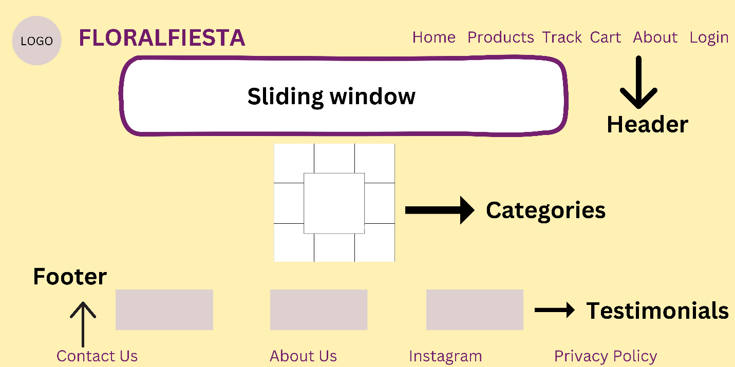

**LOGIN PAGE:**

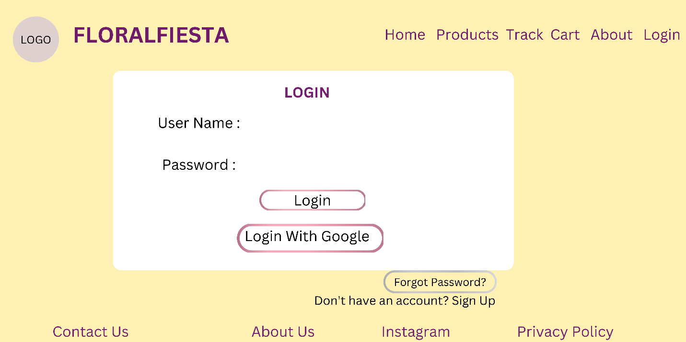

**PRODUCTS PAGE:**

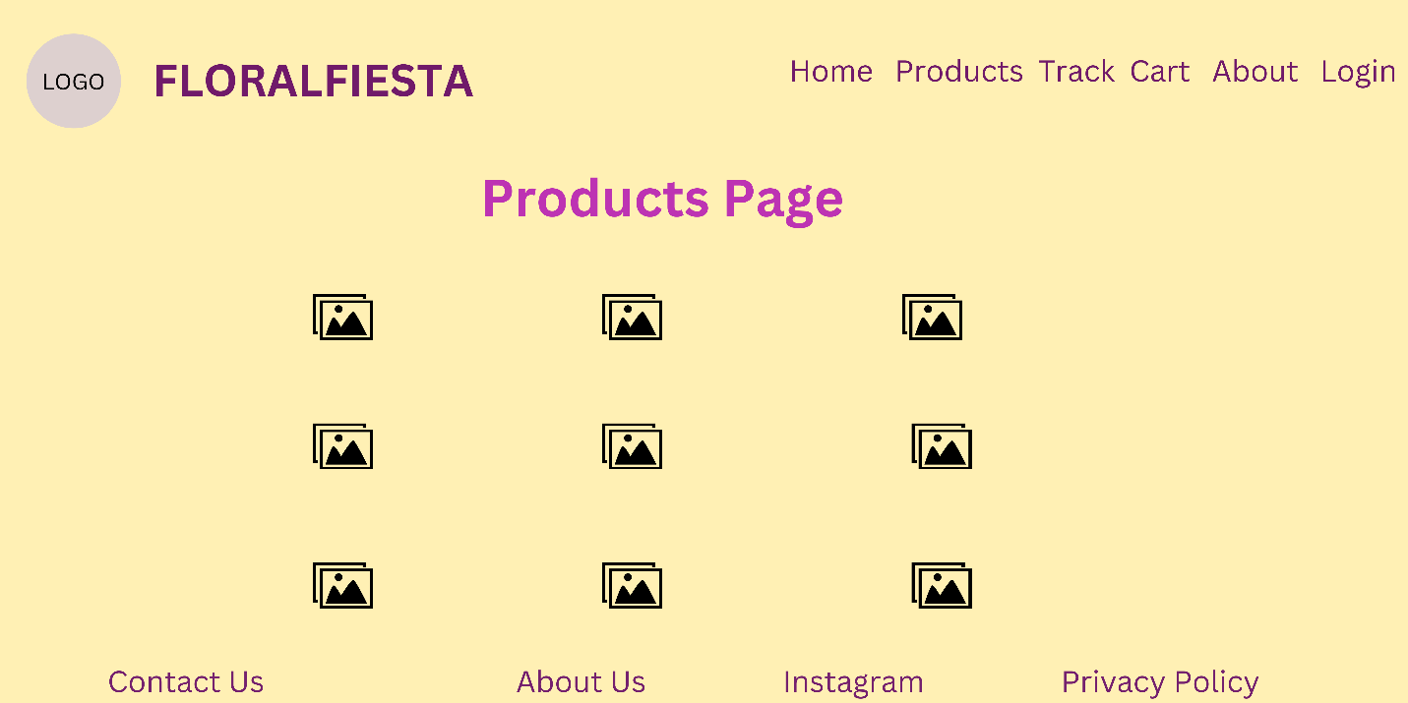

**CART PAGE:**

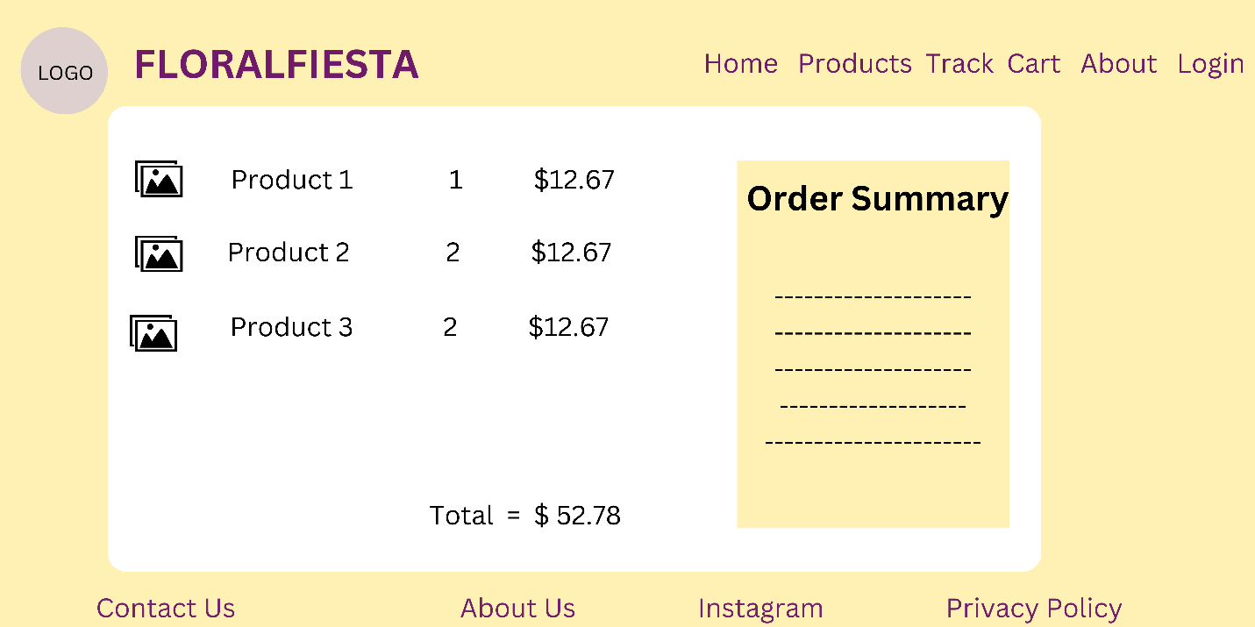

**ABOUT US PAGE:**

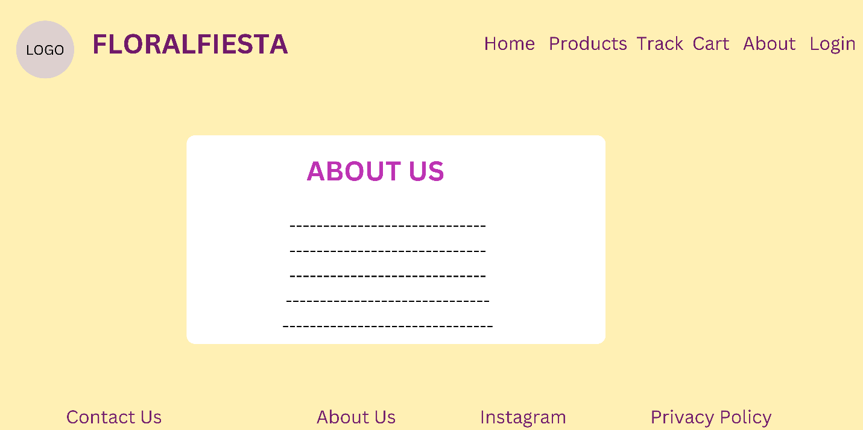

**CHECKOUT PAGE:**

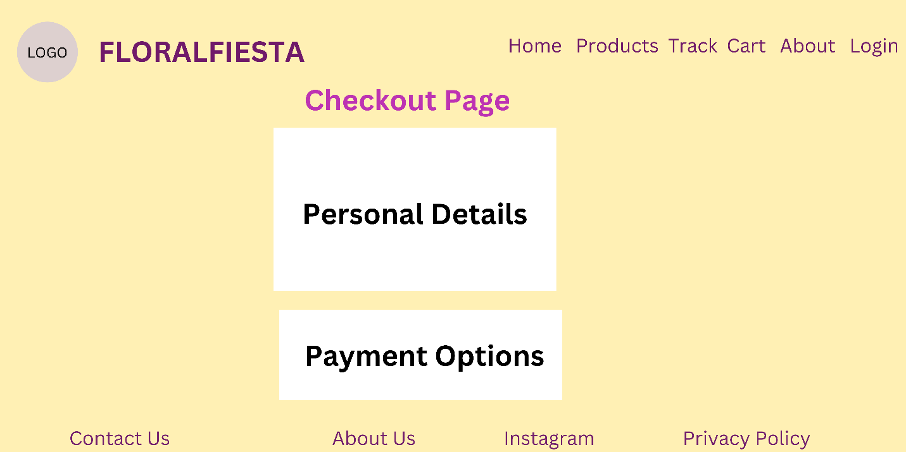

**CONTACT US PAGE:**

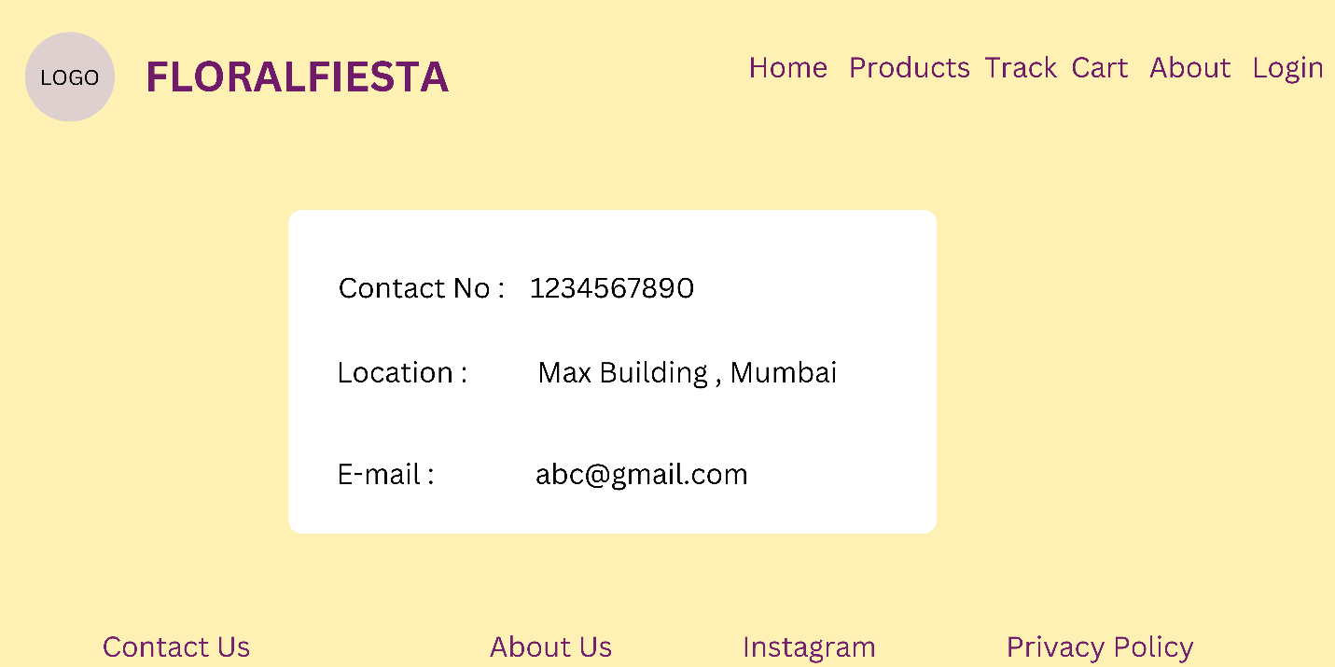

**Track Your Order Page:**

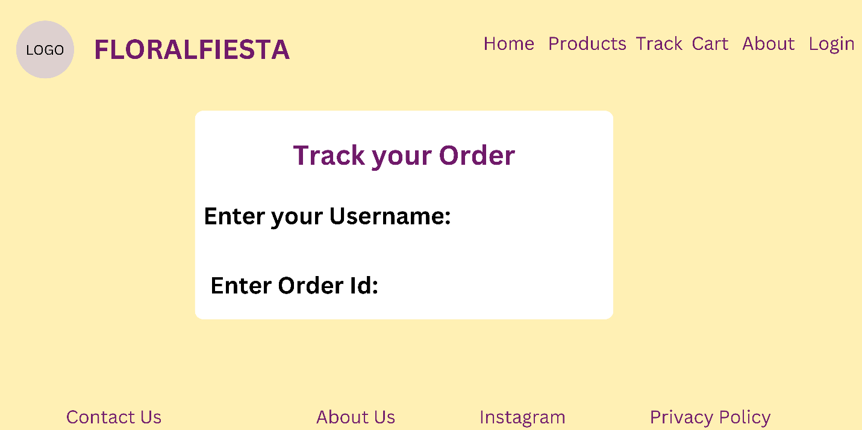

~ Aniket Jaiswal

Sanika Ingle

Rohit Patil